September 27, 2005

President George W. Bush
The White House
1600 Pennsylvania Avenue, NW
Washington, DC 20500

Dear President Bush:

With your nomination of Judge John Roberts for the position of Chief Justice of the Supreme Court, you now have an unprecedented opportunity to revisit the appropriate replacement for Justice Sandra Day O’Connor. On behalf of the National Association of Women Judges (NAWJ), I again urge you, at this watershed moment in the shaping of the Court, to heed the chorus of calls for the appointment of a woman who will follow Justice O’Connor’s example of independence, pragmatism, insistence on applying the law to the particular facts before the Court, and responsiveness, in her own words, “to those at the bottom and the margins of the social order.”

Since Justice O’Connor’s landmark appointment in1981, great strides have been made toward the achievement of broad representation of women on federal and state courts, including the almost two dozen women currently serving as chief justices of their state’s highest court. But women are still far from being equally represented at the higher reaches of the bench--just as they remain underrepresented in other fields of professional endeavor. With this critical nomination again before you, we would once again urge you to make clear to the nation your commitment to the full and equal participation of women in American society by nominating a distinguished woman jurist in the mold of Justice O’Connor.

The field of potential women nominees includes a wide array of extraordinarily well qualified federal and state appellate judges, and NAWJ remains eager to provide you and your advisors with any information you may seek about these distinguished jurists.

NAWJ was founded in 1979 as a nonpartisan association of judges with the mission to ensure equal justice and access to the courts for women and
other vulnerable populations; to increase the numbers, advancement and leadership status of women on the bench to accurately reflect the role of women in a democratic society; to preserve judicial independence; and to serve as a leading provider of cutting-edge judicial training initiatives focused on issues of particular importance to women and their families.

As we earlier wrote you, NAWJ believes that only by maintaining, and in the future increasing, the current levels on the Court of talented, experienced and compassionate women can we truly safeguard the right of women to seek fulfillment of their highest aspirations and bring their talents and perspectives to bear on the important issues before the Court.

Your selection of Justice O’Connor’s replacement represents an historic opportunity for you to reaffirm the importance and meaning of her landmark appointment, by confirming the permanent and rightful presence of women on the Court.
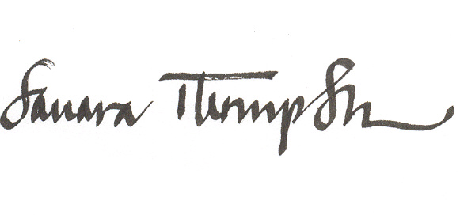
Sincerely,

Judge Sandra Thompson
President

