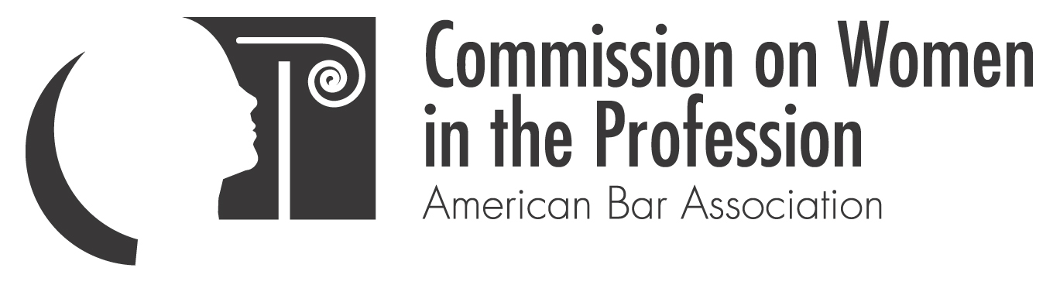

Mindbugs: The Psychology of Ordinary Prejudice

Featuring: Professor Mahzarin Banaji
Richard Clarke Cabot Professor of Social Ethics
Department of Psychology
Harvard University

Date: Friday, February 13, 2009

Location: Room 312, Level 3
Hynes Convention Center
900 Boylston Street, Boston, MA

Time: 10:00 a.m. – 12 noon

Cost: ABA members $20; Non-members $30;
Law students (with student id) $10

Registration: www.abanet.org/women/midyear/mindbugs.html

Note the cut-off for advance registration is February 5, 2009. After February 5, participants must register on-site and an additional $5 will be charged. Seating is limited, please register today.

Prejudiced? Of course, we all are. Though we may believe that our own views are not affected by stereotypes or bias, the reality is surprisingly different.

This highly participatory discussion will be led by the renowned Harvard Professor Mahzarin Banaji, who will educate us on the effects of implicit and unconscious biases on all members of the legal profession. These subtle biases influence how we perceive our clients and witnesses, interact with other attorneys and judges and attempt to persuade juries. On a day to day basis, they even affect how we make decisions on hiring, work distribution, evaluations, promotions and layoffs.

Professor Banaji conducted groundbreaking research on mental processes that operate without our awareness, intention or control. Biases can actually be measured, as Professor Banaji co-developed the Implicit Association Test nearly a decade ago. This highly regarded test, as well as physiologic measures, can help us to understand how we view each other.

CLE credit has been requested.

ABA Co-sponsors: Center for Racial and Ethnic Diversity; Commission on Lawyer Assistance Programs; Commission on Mental and Physical Disability Law; Commission on Sexual Orientation and Gender Identity; Forum on Communications Law; General Practice, Solo and Small Firm Division; Government & Public Sector Lawyers Division; Health Law Section; Law Practice Management Section; Section of Family Law; Section of Individual Rights & Responsibilities; Section of Intellectual Property Law; Section of International Law; Section of Litigation; Section of Public Utility, Communications and Transportation Law; Standing Committee on Pro Bono and Public Service; Tort Trial & Insurance Practice Section; and Young Lawyers Division

Other Co-sponsors: National Association of Women Judges, National Association of Women Lawyers, and National Conference of Women’s Bar Associations

